

Tribhuvan University
Faculty of Humanities and Social Science

House Rental Management System

A PROJECT REPORT

Submitted to
Department of Computer Application

National Infotech College Pvt. Ltd.

In partial fulfillment of the requirements for the Bachelors in Computer Application

Submitted By

Mamata kumari gupta
Reg No. 6-2-1178-9-2020

Pratiksha kumari sah,
Reg. No. 6-2-1178-16-2020

Under the Supervision of

Amrendra Chaurasia



Tribhuvan University

Faculty of Humanities and Social Science

Supervisor’s Recommendation

I hereby recommend that this project prepared under my supervision by Pratiksha kumari sah and mamata kumari gupta entitled “House Rental Management System” in partial fulfillment of the requirements for the degree of Bachelor of Computer Application is recommended for the final evaluation.



……………………………..

SIGNATURE

Amrendra Chaurasia

SUPERVISOR
Software Engineer
BCA Shiromani Tole, Birgunj (Nepal)



Tribhuvan University
Faculty of Humanities and Social Science

National Infotech College Pvt. Ltd.

LETTER OF APPROVAL

This is to certify that this project prepared by Pratiksha kumari sah and mamata kumari gupta entitled “House Rental management” in partial fulfillment of the requirements for the degree of Bachelor in Computer Application has been evaluated. In our opinion it is satisfactory in the scope and quality as a project for the required degree.

iii
SIGNATURE of Supervisor  Amrendra Chaurasia  BCA (Shiromani Tole, Birgunj) | ………………….  SIGNATURE of HOD/Coordinator  Bijay Kushwaha, M Phil  BCA (Shiromani Tole, Birgunj)
…………………………… SIGNATURE of Internal Examiner Internal Examiner | ……………………………………… SIGNATURE of External Examiner External Examiner

Abstract
House Rental Management System Software is an online system developed to assist in and automate the entire process of rental property management. It supports property owners, managers, and tenants in carrying out major activities like listing properties, screening tenants, making rental agreements, collecting rent, and managing the maintenance-related issues.
It enables landlords and property managers to put the description of their properties with details, like images and specifications of the rent. Prospective tenants will go through the properties, fill in their applications, and sign lease agreements online. The system incorporates the facility of secure online payment processing for rent collections, automates the billing process, and sends notifications of upcoming payments and lease renewals.
The system also has a built-in maintenance module where tenants can log their requests, and the landlord ensures issues pertaining to property are tracked and resolved. Rich reporting and analytics functionality lets landlords and property managers see the incoming rent, occupancy of tenants, and maintenance costs.
House Rental Management System Software decreases manual labors, reduces the possibility of errors, enhances communications between landlords and tenants, and raises the bar of efficiency in property management operations on an integrated user-friendly interface.

Acknowledgement
This project titled "House Rental Management System" has been meticulously developed as part of the requirements for the attainment of a Bachelor of Computer Application (BCA) degree. The fruition of this endeavor owes itself to the unwavering support and collaborative efforts of various individuals, for which I am deeply appreciative.
Foremost, my heartfelt gratitude goes to Mr. Amrendra Chaurasia, my esteemed Project Teacher, who entrusted me with the opportunity to delve into novel concepts within our module, encompassing Routing, Middleware, OTP, Blade, View, Database, and more. His invaluable guidance and recommendations have been instrumental in navigating the challenges encountered during the project's evolution. I would also like to extend my thanks to our esteemed educators, whose motivation and inspiration propelled me towards the project's successful culmination.
In addition to my Project Teacher, I extend my gratitude to Coordinator Bijay Sir, who adeptly facilitated the assignment of a knowledgeable resource to aid me in comprehending intricate aspects of the project's objectives. His commitment to ensuring timely project completion is commendable, and I am appreciative of his dedication.
Lastly, my sincere acknowledgments are extended to all those who, whether directly or indirectly, contributed to the realization of this project. Their involvement and assistance have been invaluable in shaping the project's trajectory.

Pratikhsa kumari sah
Mamata kumari gupta
BCA 6th Semester

Table Of Content
Chapter 1: Introduction

  - Introduction 1
  - Problem Statement 2
  - Objectives 4
  - Scope and Limitation 7
  - Development Methodology 8
Chapter 2: Background Study and Literature Review
  - Background Study 12
  - Literature Review 13
Chapter 3: System Analysis and Design
  - System Analysis 14
  - System Design (Structured Approach/Object-Oriented Approach).........................18
  - Algorithm details…………………………………………………………………..23
Chapter 4: Implementation and Testing
  - Implementation 33
  - Testing ..35
Chapter 5: Conclusion and Future Recommendations
  - Conclusion 36
  - Lesson learnt/Outcome. 37
  - References 39

Chapter 1: Introduction
1.1 introduction
Managing rental properties has traditionally been a challenging and time-consuming task, involving various activities such as tenant screening, rent collection, and lease management. As urban areas continue to grow, property managers and landlords are increasingly struggling to manage their properties efficiently while ensuring tenant satisfaction. With the rental housing market on the rise, one thing is clear: the demand for rental properties has likely never been higher.
This presents a significant opportunity: the creation of a House Rental Management System that addresses the inefficiencies in managing these processes. This system encompasses the entire rental cycle, creating a cohesive marketplace that connects landlords, tenants, service providers, and property managers for smooth transactions. This paper explores the design and implementation of the House Rental Management System.
The Rental Management System is an excellent tool for finding houses, apartments, offices, or paying guest accommodations. These reasons highlight how this system simplifies the house rental process through an online platform.

1.2 Problem Statement
Managing rental properties is a complex and often burdensome process that challenges landlords, property managers, and tenants. Such massive sizes of properties are becoming a bit too complicated to handle as it has been unrealistic for any individual who owns the property (or several) in high rental demand urban areas. In many cases, the team is trying to organize a litany of ever-growing documentation via email, texting, and some sophomoric software that was never designed for managing rental properties — at least not effectively. Traditional methods (manual processes) are kludgy/disjointed, inefficient, and subject to error/miscommunication.
Landlords and property managers have much to do, from getting properties listed for rent and screening potential tenants through managing lease agreements while at the same time collecting rent with maintenance requests coming in hot. Managing these tasks manually or via different systems causes delays, errors, and higher operational costs. Don't forget, that tenants also struggle to find good rentals and organize leases, pay rent on time as well.

Objectives

The primary objective of the House Rental Management System is to develop a comprehensive, user-friendly platform that streamlines and automates the management of rental properties. This system aims to enhance the efficiency and effectiveness of property management processes for landlords, property managers, and tenants.

Specifically, the objectives of the House Rental Management System are:

1. To simplify the process of listing and managing rental properties by providing an intuitive interface for property owners to update and maintain property details, including availability, pricing, and features.

2. To improve tenant management by offering tools for screening tenants, managing lease agreements, and tracking tenant history, ensuring that property managers can efficiently handle tenant-related tasks.

3. To automate rent collection and financial tracking, enabling seamless payment processes, timely rent reminders, and accurate financial reporting, thereby reducing the administrative burden on property managers and minimizing the risk of payment delays.

4. To facilitate effective communication between landlords, property managers, and tenants, ensuring that maintenance requests, inquiries, and other communications are handled promptly and efficiently through a centralized system.

5. To provide tenants with an easy-to-use platform for searching, comparing, and securing rental properties that meet their needs, while also giving them access to important information such as lease terms and payment history.

6. To reduce operational costs and improve overall property management efficiency by integrating all essential functions into a single platform, thereby eliminating the need for multiple, disjointed systems.

1.4 Scope and Limitation
Property Listing Management: Landlords and property management professionals will be able to list their available properties in different categories like apartments, houses, offices or paying guest accommodations on the app. This information would include details of rent, place and floor size, characteristics etc.
Tenant Management: The system will allow all types of tenant records to be saved, listed and managed- From being able to screen potential renters (or not), make a lease agreement or structure rental history. This storage can securely store tenant data for retrieval.
Rent collection automation: The system will automate the rent collections processes, it allows your tenants with multiple payment options and reminders of payments that are due. Real-time financial reports and transaction histories available to property managers
Maintenance Requests: Tenants can submit maintenance requests via the system and let property managers know what needs to be addressed

Limitations:
Initial Setup and Data Entry: The system requires an initial investment of time and resources to set up and input all relevant data about properties, tenants, and leases. This may be a barrier for some users, especially those managing large portfolios.
Internet Dependence: The system is dependent on an active internet connection for accessing and managing information. Users in areas with poor connectivity may experience difficulties in using the system.
Customization Constraints: While the system is designed to be flexible, it may not accommodate every specific need or preference of property owners or managers, especially those with unique or non-standard requirements.
Technical Support and Maintenance: The effectiveness of the system relies on continuous technical support and regular maintenance. Users may face challenges if the system encounters technical issues or if updates are not implemented promptly.
Data Security Concerns: Although the system will incorporate security measures, there is always a risk of data breaches or unauthorized access, which could compromise sensitive information related to properties, tenants, and financial transactions.
Scalability Limits: While the system is designed to handle a substantial number of properties, there may be limitations in its ability to scale efficiently if the portfolio grows exponentially, requiring further upgrades or customizations.
Learning Curve: Users may need time to familiarize themselves with the system's features and functionalities. This learning curve could initially slow down adoption and productivity.
Legal and Regulatory Compliance: The system may need to be adapted to comply with local laws and regulations regarding rental property management, which could vary by region.
1.5 Development Methodology:
The development of the House Rental Management System follows a structured and systematic approach to ensure the creation of a robust, scalable, and user-friendly platform. The methodology combines elements of both Agile and Waterfall models, enabling flexibility in development while maintaining a clear progression through defined stages. The following outlines the key phases involved in the development of the system:

Requirement Gathering and Analysis
- Stakeholder Interviews: Engage with landlords, property managers, and tenants to understand their needs, pain points, and expectations from the system.
- System Requirements Specification (SRS): Document all functional and non-functional requirements, including user roles, system features, performance criteria, and security measures.
- Feasibility Study: Assess the technical, operational, and financial feasibility of the project to ensure that the system can be developed within the given constraints.

System Design
- Architecture Design: Define the overall system architecture, including the choice of a three-tier architecture (presentation, application, and data layers) to separate concerns and enhance scalability.
- Database Design: Design the database schema to organize data efficiently. This includes defining tables for properties, tenants, leases, payments, and maintenance requests.
- User Interface (UI) Design: Develop wireframes and mockups for the user interface, ensuring that the system is intuitive and accessible for all users.
- Technology Stack Selection: Choose appropriate technologies for development, such as programming languages (e.g., JavaScript, Python), frameworks (e.g., React, Django), and database management systems (e.g., MySQL, PostgreSQL).

Development
- Module Development: Break down the system into smaller modules based on functionalities, such as property management, tenant management, payment processing, and maintenance tracking. Develop and test each module individually.
- Integration: Integrate the modules to create a cohesive system. Ensure that the modules interact seamlessly, with data flowing accurately between different parts of the system.
- API Development: Develop APIs for any external integrations required, such as payment gateways, SMS/email notifications, or third-party property listing services.

Testing
- Unit Testing: Test individual modules to ensure that each one functions correctly in isolation.
- Integration Testing: Test the integrated system to verify that all modules work together as intended.
- User Acceptance Testing (UAT): Involve end-users in testing the system to ensure it meets their needs and expectations. Gather feedback and make necessary adjustments.
- Performance Testing: Evaluate the system’s performance under various conditions, including load testing to ensure it can handle multiple users and large datasets.

Deployment
- Staging Environment Setup: Deploy the system in a staging environment that mirrors the production environment for final testing and quality assurance.
- Data Migration: If applicable, migrate existing data from legacy systems to the new House Rental Management System.
- Production Deployment: Deploy the system to the live environment, ensuring minimal downtime and disruption to users.

Training and Documentation
- User Training: Provide training sessions for landlords, property managers, and tenants to familiarize them with the system’s features and functionalities.
- Documentation: Prepare comprehensive user manuals, technical documentation, and support guides to assist users and developers in understanding and maintaining the system.

Maintenance and Support
- Ongoing Support: Offer ongoing technical support to address any issues that arise post-deployment.
- System Updates: Regularly update the system to incorporate new features, fix bugs, and enhance security.
- Feedback Loop: Establish a feedback mechanism to continuously gather input from users for future improvements and iterations of the system.

Project Management and Monitoring
- Agile Sprints: Utilize Agile methodologies, such as Scrum, to break the development process into sprints, allowing for iterative development and regular reviews.
- Progress Tracking: Use project management tools (e.g., Jira, Trello) to monitor progress, manage tasks, and ensure that the project stays on schedule and within budget.
- Quality Assurance: Implement continuous quality assurance practices throughout the development lifecycle to maintain high standards of software quality.

Chapter 2: Background Study and Literature Review

2.1 Background Study
In Nepal, the housing sector has seen significant growth, particularly in urban areas such as Kathmandu, Pokhara, and other emerging cities. With rapid urbanization, there has been an increasing demand for rental properties, including apartments, houses, offices, and paying guest accommodations. This demand is driven by several factors, including population growth, migration to urban centers for employment and education, and the rise of the middle class seeking better living standards.
Despite this growth, the rental housing market in Nepal faces numerous challenges. Traditionally, the management of rental properties has been handled manually, with property owners and managers relying on paper records or basic digital tools like spreadsheets. This approach often leads to inefficiencies, including difficulties in tracking rent payments, managing tenant information, and handling maintenance requests. Moreover, the lack of a centralized system for listing properties means that tenants frequently struggle to find suitable rental options, leading to a time-consuming and frustrating search process.
The absence of a streamlined management system has resulted in several issues for both landlords and tenants in Nepal:
- Inefficient Property Management: Many landlords and property managers are burdened by the manual processes involved in managing multiple properties. This often results in delayed rent collection, mismanagement of tenant records, and inadequate handling of maintenance issues.
- Tenant Frustration: Tenants often face challenges in finding rental properties that meet their needs due to the lack of a centralized platform where available properties are listed. Additionally, communication between tenants and landlords can be slow and cumbersome, particularly when addressing maintenance requests or negotiating lease terms.
- Lack of Transparency: The traditional methods of managing rental properties in Nepal often lack transparency, leading to potential disputes between landlords and tenants over lease agreements, rent increases, and maintenance responsibilities.
- Limited Use of Technology: Although digital technology has begun to penetrate various sectors in Nepal, the housing rental market has been slow to adopt modern management.

Literature Review
The development of a House Rental Management System in Nepal is a response to the growing complexities and inefficiencies in the rental housing market. This literature review explores existing studies, theories, and technologies related to rental management systems, with a focus on their application in Nepal’s context.
The rental housing market in Nepal, particularly in urban areas, has expanded significantly due to rapid urbanization, population growth, and increased migration to cities. Studies by organizations such as the Central Bureau of Statistics (CBS) in Nepal highlight that urbanization is expected to continue rising, leading to greater demand for rental housing (CBS, 2021). This trend has prompted the need for more effective management of rental properties to meet the needs of both landlords and tenants.
Traditional methods of managing rental properties in Nepal are heavily reliant on manual processes, such as paper-based record-keeping and face-to-face communication. These methods are not only time-consuming but also prone to errors and inefficiencies (Adhikari, 2020). A study by Adhikari (2020) found that property managers often struggle with maintaining accurate records, collecting rent on time, and addressing maintenance requests promptly. The lack of a centralized system for managing these tasks exacerbates these issues, leading to tenant dissatisfaction and increased operational costs for landlords.
Globally, the adoption of digital solutions for rental management has been on the rise, with systems designed to automate and streamline various aspects of property management. These systems offer features such as online property listings, automated rent collection, tenant screening, and maintenance management (Zhou & Wang, 2018). The literature suggests that these systems can significantly improve efficiency, reduce operational costs, and enhance tenant satisfaction (Zhou & Wang, 2018; Smith & Lee, 2019)
Several case studies from other developing countries provide insights into how rental management systems have been successfully implemented. For example, in India, the introduction of digital rental platforms has transformed the rental housing market by providing centralized databases of available properties and facilitating online transactions (Patel & Desai, 2020). These platforms have improved transparency and efficiency, making the rental process more accessible for both landlords and tenants.

Chapter 3: System Analysis and Design

System Analysis

The House Rental Management System Software is designed to automate and simplify the process of managing rental properties for landlords, tenants, and property managers. The analysis phase is critical in understanding the system's requirements, functionality, and overall architecture. This section outlines the analysis of the system, including problem identification, feasibility, and system requirements.

Requirements Analysis

The requirements for the system are divided into two categories: functional and non-functional requirements.

Functional Requirements

User Registration and Authentication: Landlords and tenants can create accounts and log in to access system features.

Property Management: Landlords can add, update, and delete property listings with details such as rent, location, and amenities.

Tenant Application: Prospective tenants can search and apply for rental properties through the system.

Rental Agreements: The system allows for the creation and storage of digital lease agreements between landlords and tenants.

Rent Payment Management: Tenants can pay rent through a secure online payment system. Landlords can view payment statuses and generate receipts.

Maintenance Requests: Tenants can submit maintenance requests, and landlords or property managers can track and resolve them.

Notifications and Alerts: Automatic notifications are sent for upcoming rent payments, lease expirations, and maintenance status updates.

Reporting: The system provides reports on rental income, tenant occupancy, and other financial and operational data for property managers.

Requirement Analysis

Functional Requirements (Use-case description):
The news house rental functional requirements are outlined through detailed use-case descriptions that depict the interactions between users and the system.
User Authentication and Personalization (Use-case: User Login and Personalization):

  - Description: Users should be able to create accounts, log in, and personalize their news feed based on their interests.
  - Actors: User

  - Precondition: User has registered an account.

  - Main Flow:

- User accesses the portal and clicks on the login button.

- System prompts for credentials (username and password).

- User enters valid credentials and clicks "Login."

- System verifies credentials and redirects the user to the personalized dashboard.
  - Postcondition: User gains access to a personalized news feed.

System Design

The system design follows the multilayer architecture with the following layers:

Presentation Layer: This deals with the representation of the interface with which users will interact through a web or mobile application.
Application Layer: This layer will implement the business rules pertaining to property management, rental processing, tenant management, and maintenance requests.
Data Layer: It manages data storage and retrieval of properties, tenants, and payments and maintenance thereof.

Tools and Technologies
The following tools and technologies are recommended for developing the House Rental

Management System:

- Frontend: HTML, CSS, JavaScript, Bootstrap, Angular/React (for responsive and dynamic user interfaces).
- Backend: PHP, or Java (for server-side logic), and frameworks like Django or Laravel.
- Database: MySQL or PostgreSQL (for data storage).
- Payment Integration: APIs such as PayPal or Stripe for online payment processing.
- Version Control: GitHub or GitLab for source code management.

Feasibility Analysis (Technical, Operational, Economic)
Feasibility analysis remains a pivotal aspect of the project, which involves developing a house rental management system using PHP for the frontend and Node.js for the backend. The analysis assesses the project's viability and suitability from various dimensions: technical, operational, and economic.
Technical Feasibility: •
Frontend: HTML5, CSS3, JavaScript, and frameworks like Angular, React, or Vue.js to create responsive and user-friendly interfaces for both landlords and tenants. These technologies are widely used, scalable, and efficient for dynamic web applications.
Backend: PHP (with Laravel framework), Python (with Django/Flask framework), or Java (with Spring framework) can be used to handle business logic, user authentication, and interactions with the database. These technologies are widely supported, scalable, and offer strong community support.
Operational Feasibility: The operational feasibility of the project is favorable, given the prevalence of skilled developers familiar with React.js and Node.js in the industry. The project team's expertise ensures the effective implementation of the portal, seamless integration with operational workflows, and the ability to maintain and update the system as needed.
Economic Feasibility: The economic feasibility analysis takes into account the costs associated with using React.js and Node.js for development, along with potential benefits. While there might be certain development and licensing costs, the availability of open- source tools and a strong developer community contributes to cost-effectiveness. Moreover, the projected benefits, such as a user-friendly interface, real-time updates, and potential revenue streams, such as advertisements or premium features, can outweigh the initial investment, ensuring a positive economic outcome.

Data Modelling: Entity-Relationship (ER) Diagram
The Entity-Relationship (ER) diagram is used to visually represent the data structure and relationships within the house rental management system. It identifies entities (such as tenant, house, report, payment, house type etc) and their attributes, along with the relationships between them. The ER diagram helps in understanding the database design and the flow of data throughout the system.

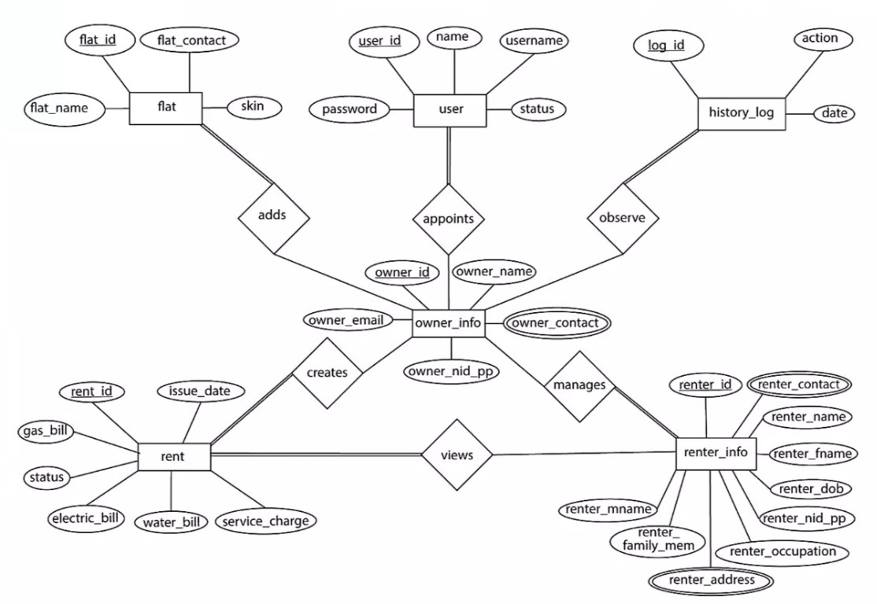

Fig.2- Entity-Relationship (ER) Diagram

    - Process Modelling: Data Flow Diagram (DFD)
In the symphony of process modelling, the Data Flow Diagram (DFD) manifests as a harmonious melody that resonates with the intricacies of system processes. Through a cascade of processes, data flows, and data stores, the DFD casts a spotlight on the orchestration of data, illuminating the choreography of inputs, transformations, and outputs.

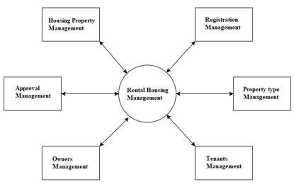

Fig3: Data flow diagram
3.1.5 Use case diagram (DFD)
A House Rental Management System involves multiple users and features that allow landlords, tenants, and administrators to manage rental properties efficiently. Here's a Use Case Diagram description for a house rental management system:

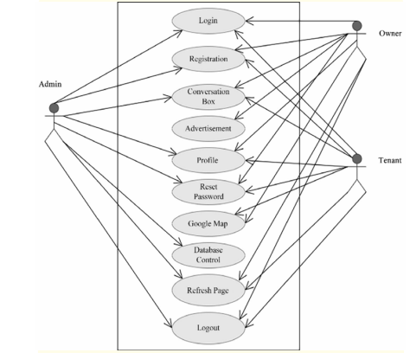

Fig4: Use case diagram

Flowchart diagram:

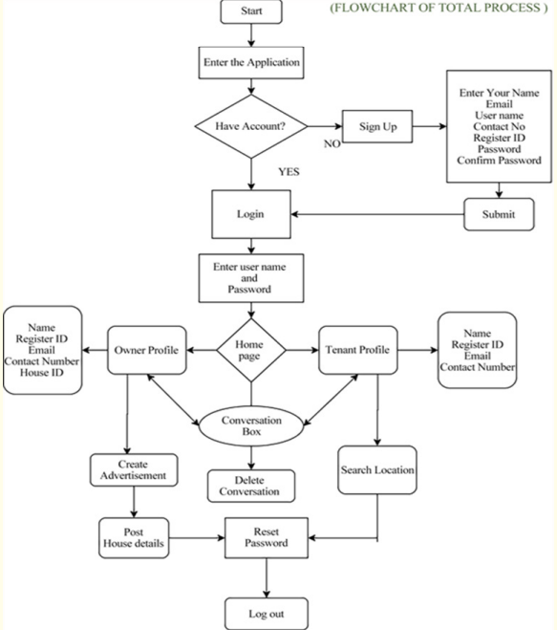

Fig: flowchart showing the work flow of rental house management system

3.1 System Design (Structured Approach/Object-Oriented Approach)
The structured approach focuses on breaking down the system into a series of functional modules, where each module performs a specific function of the system. This design approach emphasizes processes rather than data, and it is more suited for smaller, simpler systems.

Data Flow Diagram (DFD):
Level 0: Shows the main system interacting with external entities (landlord, tenant, payment system).
Level 1: Breaks down the system into key modules like property management, rental management, payment management, and user management.

Modular Structure:
Property Management: Handles adding, updating, or deleting property listings.
Rental Management: Manages tenant inquiries, lease agreements, and maintenance requests.
Payment Processing: Manages the collection of rental payments, generating invoices, and tracking due dates.
User Management: Manages user accounts for landlords and tenants, including login and registration.

Object-Oriented Approach (OOD)
The object-oriented approach emphasizes objects, which combine both data and behavior (methods). This approach makes the system more modular, scalable, and reusable by focusing on entities as real-world objects and their interactions.

Class Diagram:
Landlord: Attributes like name, contactInfo, propertiesOwned. Methods for addProperty(), updateProperty(), removeProperty().
Tenant: Attributes like name, contactInfo, rentalHistory. Methods for searchProperty(), requestLease(), payRent().
Property: Attributes like address, price, availability. Methods for listProperty(), updateDetails(), deleteProperty().
Rental Agreement: Attributes like leaseStartDate, leaseEndDate, rentAmount. Methods for createLease(), terminateLease().
Payment: Attributes like paymentID, amount, dueDate. Methods for makePayment(), generateInvoice().

Use of Inheritance and Polymorphism:
A User class can be a parent class, with Landlord and Tenant as its subclasses. Shared attributes like username and password can be inherited.

Sequence Diagram:
Illustrates interactions between objects, such as when a tenant searches for a property, requests a lease, and makes a payment.

Architectural Design
Designing an architecture for a House Rental Management System (HRMS) involves structuring various modules to efficiently manage property rentals, including property listing, tenant management, lease agreements, and payment tracking. Below is a high-level architecture for such a system, focusing on modularity, scalability, and ease of integration.
Client-Side (Frontend):
Web/Mobile Interface (React, Angular, Vue.js, Flutter)
User Interface (Landlords, Tenants, Admins)

Backend:
- RESTful API (Node.js, Python Flask/Django, Java Spring Boot)
- Business Logic Layer (Property Management, Lease Management)
- Database (SQL/NoSQL)

Data Storage:
- Relational Database (PostgreSQL, MySQL) or NoSQL (MongoDB) for storing structured data
- File Storage (AWS S3, Google Cloud Storage) for document management (lease agreements, images)

Modules of HRMS

User Management Module
- Authentication (OAuth, JWT tokens, Password Encryption)
- Role-Based Access (Landlords, Tenants, Admins)
- User Profile Management
Property Management Module:
- Property Listings (Add, Edit, Delete)
- Property Availability and Occupancy Status
- Property Media (Images, Videos)

Lease and Contract Management:
- Lease Agreement Creation and Storage (PDF uploads, Digital Signatures)
- Lease Renewal/Termination
- Rent Schedule (Due Dates, Notices)

Payment and Billing Module:
- Rent Collection and Payment Tracking
- Payment Gateway Integration (Stripe/PayPal for secure payments)
- Invoices and Receipts Generation

Tenant Management Module:
- Tenant Profile (Contact Details, Lease Information)
- Tenant Requests (Maintenance, Complaints)
- Rent Payment History and Notices

Maintenance and Service Management:
- Maintenance Requests (Create, Assign, Track)
- Vendor/Service Provider Management
- Service History

Notification and Alerts System:
- Email/SMS Notifications for Rent Due, Lease Expiry
- Reminders for Maintenance, Property Viewing
- Push Notifications (if mobile)

Admin/Reporting Dashboard:
- System Monitoring (Active Tenants, Total Properties, Revenue Reports)
- Export Data (CSV, Excel)
- Customizable Reports (Income, Lease Expiry, Occupancy Rate)

Database Schema Design
As the backbone of our data ecosystem, the Database Schema Design meticulously maps out the architecture of our data storage. By unfurling tables, relationships, keys, and constraints, we sculpt a digital repository that mirrors the real-world intricacies of house rent content, user interactions, and system metadata.

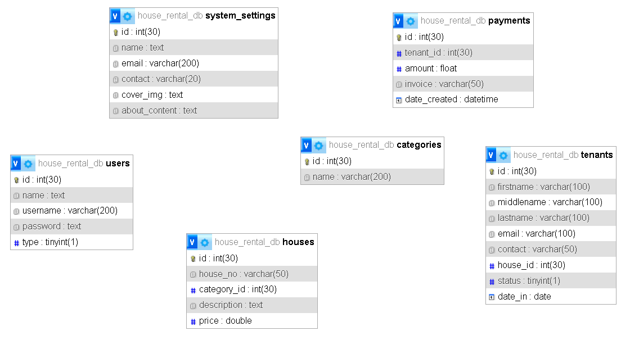

Fig.5-Database Schema Design

    - Interface Design (UI/UX)
In the interface design realm, the harmonious convergence of User Interface (UI) and User Experience (UX) crystallizes into an interactive symphony. By crafting aesthetically pleasing layouts, intuitive navigation, and captivating visuals, we forge an engaging UI that beckons users into the immersive world of our news portal. Simultaneously, the UX facets extend beyond aesthetics, embracing the ethos of usability, accessibility, and empathy to offer a seamless and satisfying user journey.

Home Page

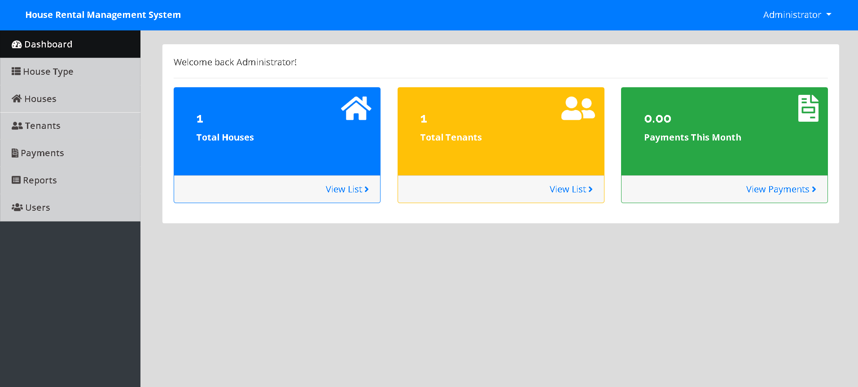

      - Tenants

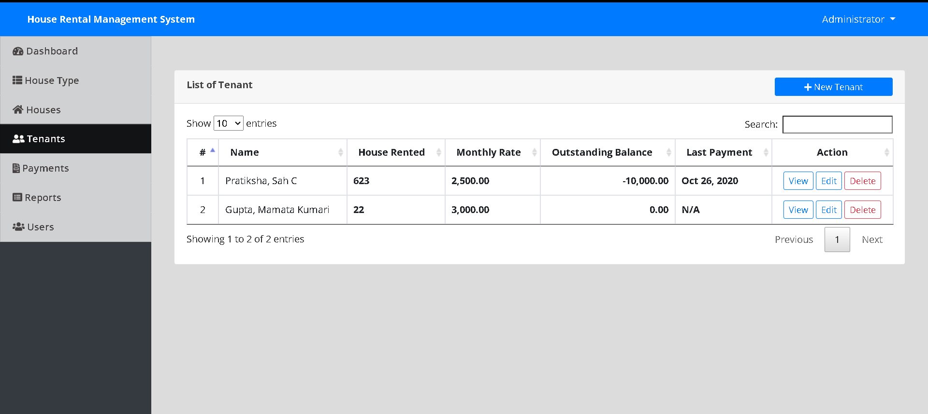

Houses

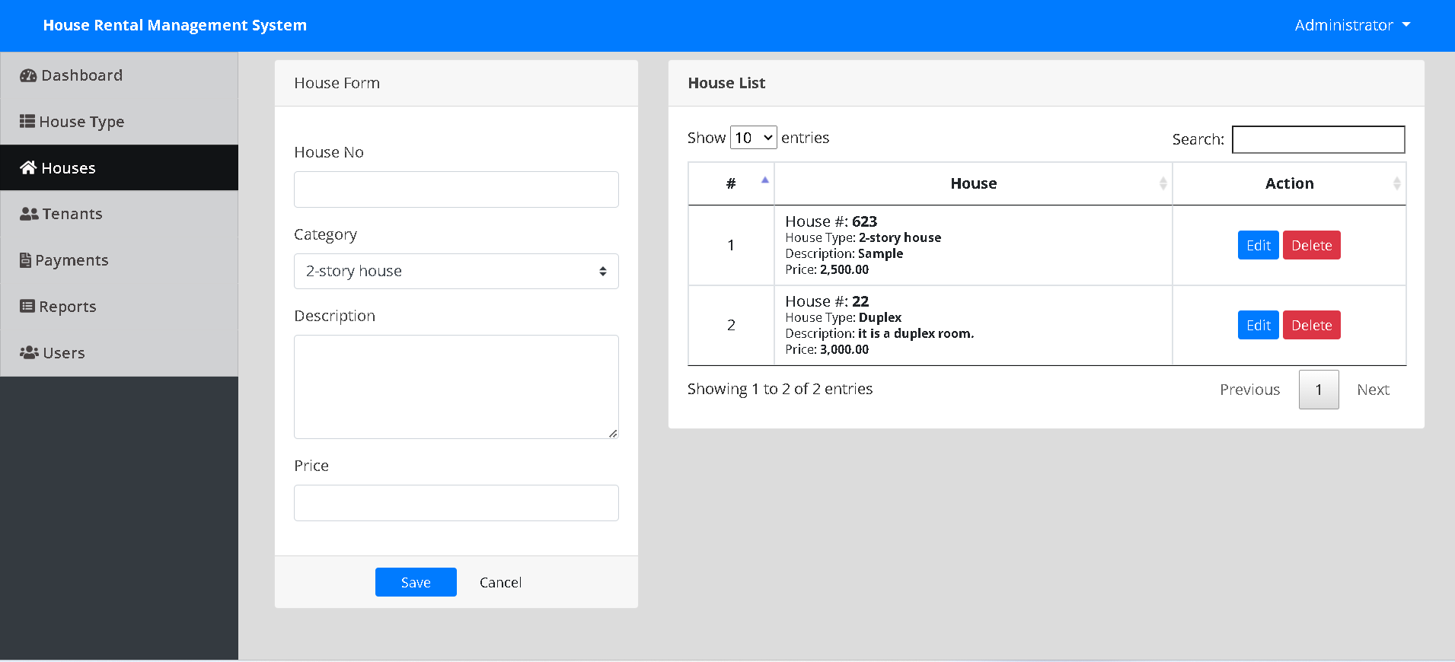

3.2.3.4 Invoices

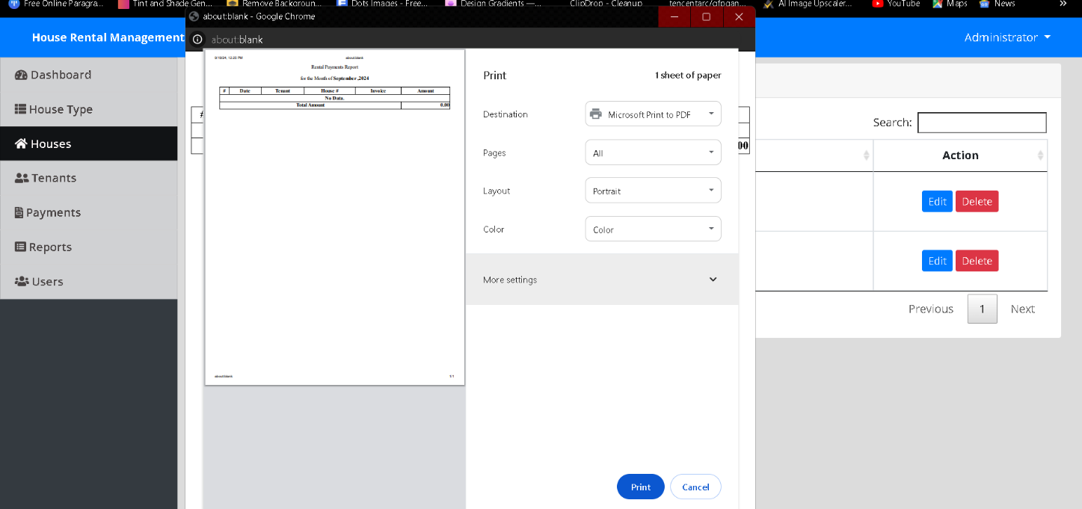

Algorithm Details

In the House Rental Management System, various algorithms are employed to handle different functionalities such as user registration, property listing, rental agreements, payments, and maintenance requests. Below is an over view of some key algorithms used in the system, described step-by-step.

User Registration Algorithm:

Steps:
- Input user details (name, email, phone number, password, user type).
- Validate email and phone number for correct format.
- Check if the email or phone number already exists in the database.
  - If yes, display error: "User already exists."
  - If no, proceed to the next step.
- Hash the user’s password for security.
- Insert the new user record into the database.
- Send a welcome notification to the user's email or phone.
- Output: "User registered successfully."

User Login Algorithm:
- Input email/username and password.
- Retrieve the user record from the database using the email/username.
- If user does not exist, display error: "User not found."
- Compare the input password with the hashed password stored in the database.
- If the password matches, allow the user to log in.
- If the password does not match, display error: "Incorrect password."
- If login is successful, create a session for the user.
- Output: "Login successful."

Create Rental Agreement Algorithm:
1. Input property ID, landlord ID, tenant ID, rent amount, start date, and end date.
- Verify that the property is available for rent.
- If not, display: "Property is not available."
- Check if the tenant already has an active rental agreement for the same property.
- If yes, display error: "Rental agreement already exists."
- Insert the rental agreement details into the database.
- Update the property’s status to "rented."
- Notify both the landlord and tenant about the new rental agreement.
- Output: "Rental agreement created successfully."

Make Payment Algorithm:
- Input tenant ID, rental agreement ID, payment amount, and payment method.
- Check if the payment amount matches the agreed rent in the rental agreement.
  - If not, display error: "Incorrect payment amount."
- Process the payment through the selected payment method (e.g., bank transfer, credit card).
- On successful payment, update the payment history in the database.
- Send a confirmation receipt to the tenant and notify the landlord of the payment.
- Output: "Payment successful."

Generate Invoice Algorithm:
1. Input payment ID.
2. Retrieve payment details from the database (payment amount, date, rental agreement ID)
3. Retrieve tenant and property details from the rental agreement.
4. Create a formatted invoice containing the payment amount, property details, and due date.
5. Send the invoice to the tenant via email or display it for download.
6. Output: "Invoice generated successfully."

Send Notification Algorithm:
- Input user ID and message content.
- Retrieve the user’s preferred notification method (email, SMS, app notification).
- Send the notification through the preferred channel.
- Log the notification in the database.
- Output: "Notification sent successfully."

Chapter 4: Implementation and Testing

Implementation
    - Tools Used (CASE Tools, Programming Languages, Database Platforms)
House rental management software project aims to develop a modern and dynamic using the PHP, React.js, and Node.js. technologies. Below are the specifications for the tools/platform, hardware, and software requirements needed for this project:
- Tools/Platform:

  - Node.js: This runtime environment will be used to execute server-side JavaScript code, enabling efficient handling of network requests and database interactions.

  - React.js: This JavaScript library will be utilized to build the user interface of the house rental, ensuring a responsive and interactive experience for users.

  - Express.js: This web application framework will be employed to establish the server- side infrastructure and handle routing and middleware operations.

- Hardware Requirements:
  - Server: A robust server is required to host the house rental software, handle incoming requests, and manage the database. The server should have sufficient CPU, memory, and storage capacity to handle anticipated traffic and content volume.
  - Database Server: A dedicated database server is necessary to store and manage content, user data, and other relevant information. The server should have adequate storage and processing capabilities to handle the expected data load.

- Software Requirements:
  - Operating System: The server should run a compatible and stable operating system such as Linux, Windows, or macOS.
  - Web Server: A reliable web server, such as Apache or Nginx, is needed to serve the static assets and handle HTTP requests.

  - Database: A suitable database management system, such as MySQL, PostgreSQL, or MongoDB, should be selected based on the project's requirements for storing and retrieving data efficiently.
  - Integrated Development Environment (IDE): An IDE like Visual Studio Code, Atom, or WebStorm can be used for coding, debugging, and version control.

  - Package Manager: NPM (Node Package Manager) is recommended to manage project dependencies and streamline the installation of required libraries and frameworks.
  - Version Control System: Git can be employed to track code changes, collaborate with a team, and maintain a version history of the project.
  - Deployment Tools: Deployment tools like Docker and Kubernetes can be utilized to package the application into containers and automate the deployment process.

Testing
    - Test Cases for Unit Testing
As we step into the real of testing, the stage is set for meticulous scrutiny of individual components. Unit testing, the cornerstone of software validation, unfurls through an ensemble of test cases. These test cases probe the depths of each module, method, and function, subjecting them to an exhaustive array of inputs and scenarios. Through this process, we unearth bugs, vulnerabilities, and logic gaps, ensuring that every building block of our application functions with precision and reliability.

Test Cases for System Testing
In the tapestry of system testing, our focus shifts from individual components to the harmonious ensemble they compose. System test cases paint a holistic portrait of our house rental management system software functionality. By orchestrating a symphony of user interactions, inputs, and scenarios, we traverse the digital thoroughfare that users navigate. This comprehensive scrutiny unearths inter-component glitches, edge case behaviour, and performance bottlenecks, ensuring that the collective system functions as a cohesive whole.

In this chapter, the digital canvas transforms into a living masterpiece, where lines of code converge into immersive user experiences, and where meticulous testing ensures reliability, robustness, and user-centricity. As the curtain rises on the implementation and testing stage, the spotlight shines on the culmination of our endeavours, where innovation, functionality, and quality converge into a harmonious crescendo that resonates with the aspirations of our house rental management system software.

Chapter 5: Conclusion and Future Recommendations

Conclusion
The House Rental Management System software offers a comprehensive and efficient solution for managing rental properties, streamlining the interactions between landlords, tenants, and administrators. By digitizing essential processes such as property listing, rental agreements, payments, and maintenance requests, the system enhances the overall user experience and reduces administrative burdens.

With the help of well-structured algorithms and refined classes, the software provides users with a seamless interface to manage property-related tasks, ensuring accuracy, security, and transparency. The automated features, such as rent reminders, maintenance tracking, and secure payments, promote timely actions and reduce the chances of errors.
Additionally, the system's scalability and flexibility make it suitable for property managers with small or large portfolios. It supports dynamic user roles (landlords, tenants, admins), ensuring that each user can access functionalities relevant to their needs. Furthermore, the inclusion of notifications and payment processing features enhances communication and financial management within the platform.
In conclusion, the House Rental Management System is a vital tool for simplifying property management tasks, fostering trust between tenants and landlords, and creating a more organized and user-friendly experience in the real estate rental market. This system helps optimize time, resources, and overall efficiency, making it a valuable asset for modern property management.

Future Recommendations
To ensure the House Rental Management System continues to meet the evolving needs of users and the property rental market, several future enhancements and features can be considered. These recommendations focus on improving user experience, expanding functionality, and increasing system efficiency.
Integration with Smart Home Technology
- Future iterations of the system could integrate with smart home devices and Internet of Things (IoT) solutions. This would allow tenants and landlords to remotely control utilities like lighting, heating, and security systems, enhancing convenience and energy efficiency.
2. Advanced Analytics and Reporting
- Incorporating advanced analytics features would help landlords and property managers generate insightful reports. Metrics such as occupancy rates, payment trends, maintenance costs, and tenant satisfaction levels could be analyzed to improve decision-making and optimize property management.
3. AI-Powered Tenant Screening
- Implementing AI-driven algorithms to assist landlords in screening potential tenants based on credit scores, past rental history, and legal records could streamline the tenant selection process, reducing the risk of issues like late payments or property damage.
4. Mobile App Development
- Developing a mobile application for the platform would offer users more flexibility by allowing them to manage their rentals on the go. Tenants could make payments, submit maintenance requests, and view agreements, while landlords could monitor properties and transactions in real-time from their smartphones.
5. Blockchain-Based Contracts
- Incorporating blockchain technology for rental agreements could enhance transparency and security. Smart contracts could automate the enforcement of agreements and rent payments, ensuring all terms are adhered to without manual intervention.
6. Improved Maintenance and Vendor Management
- The system could be enhanced with a more robust maintenance and vendor management module. This could include automated scheduling of regular property inspections, rating systems for service providers, and tools to track repair histories and costs.
7. Multilingual Support
- Adding support for multiple languages would make the platform more accessible to users from diverse backgrounds, especially in regions with multilingual populations or for international tenants and landlords.
8. Automated Legal Compliance
- A feature to automatically update legal documents and rental agreements in line with local laws and regulations would reduce the burden on landlords. This would ensure all contracts are legally compliant and help avoid potential disputes.
9. Integration with External Platforms
- Future versions could integrate with external platforms such as real estate websites, social media, and financial institutions. This would allow property listings to be automatically shared across various platforms, attracting a broader audience and offering integrated payment options.

References:

- Rastogi, R., Jain, R., Mishra, P., & Prateek. (2023). "Rental House Management System: An Empirical Approach with Simulation." Acta Scientific Computer Sciences, 5(4), 88-102.https://actascientific.com/ASCS/pdf/ASCS-05-0434.pdf

- Monirujjaman, M., et al. (2024). "Development of Online Based Smart House Renting Web Application." Scientific Research Publishing.https://www.scirp.org/journal/paperinformation?paperid=110723

- Dhamodaran, S., VenkataSai Rama Reddy, G., Gondrala, S., & Gongada, P. K. (2023). "House Rental Application System." River Publishers.https://www.riverpublishers.com/pdf/ebook/chapter/RP_9788770040723C53.pdf

- Rathore, K., Syed, A., & Patel, R. (2021). "Rental House Management System." International Research Journal of Modernization in Engineering Technology and Science, 3(5).https://www.irjmets.com/uploadedfiles/paper/volume3/issue_5_may_2021/10054/1628083403.pdf

- Gommans, H.P., Njiru, G.M., & Owange, A.N. (2014). "Rental House Management System." International Journal of Scientific and Research Publications, 4(11).https://www.ijsrp.org/research-paper-1114/ijsrp-p35101.pdf

